**High Availability Guide for GPM**

**Overview**

Goliath Performance Monitor (GPM) achieves high availability via active/passive clustering and automatic failover within your data center.  A high available system is the one that includes both redundant components and mechanisms for failure detection, as well as workload redirection. These can be a *load balancer.

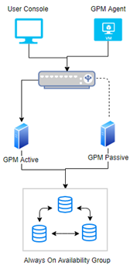

**GPM Configuration three components: Agent, Server, Database**

**Agent high availability**

GPM agents registered with GPM server should communicate with the *load balancer and on failure should automatically start communicating with the failed over GPM server.

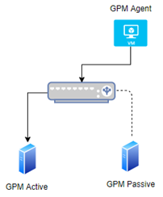

**GPM Server high availability**

**In a virtual environment.**

When a host or virtual machine (VM), with an installed GPM instance, within a cluster fails, another VM takes over and maintains the system's proper performance of the system.

**In a physical environment**

When a dedicated server with an installed GPM instance fails, another server takes over and maintains the system's proper performance of the system

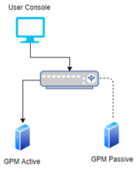

Please note, the secondary GPM Server must remain powered off, or online with the MonitorIT Server Service stopped, while the primary/active server is online. When the primary machine is offline the secondary server can be powered on/service started.

**Database high availability using SQL server**

SQL Server *Always On Availability Group* feature allows for a cluster of SQL nodes if one node goes down, then another node will maintain the proper performance of the system

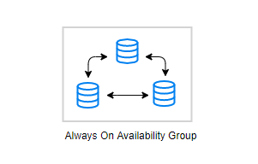

**Keep the GPM Server, Agent and Database Instances (Active/Passive in Sync)**

Any new installation/upgrade of GPM needs to be reflected in both environments.

* load balancer - DNS service with failover capability.

For installation instructions please see [Goliath Performance Monitor Installation Guide For High Availability](https://support.goliathtechnologies.com/hc/en-us/articles/7700122461335)